THE PHYSICS COLLOQUIUM
Thursday 26 January 2023, 4:00 p.m.
Nijenborgh 4, Lecture Hall 5115.0317 (Schröderzaal)

Neutron star magnetospheres
as dark matter laboratories
Sam Witte
University of Amsterdam

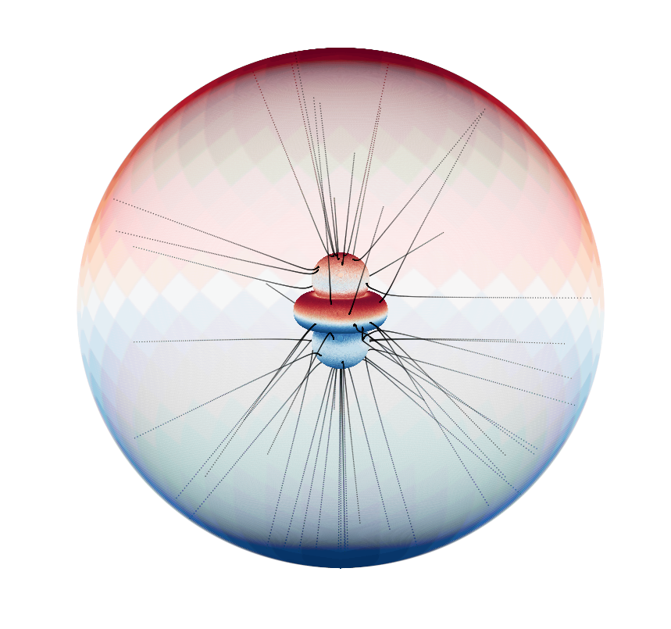
For decades, a broad array of astrophysical and cosmological observations have suggested that a large fraction of the Universe is comprised of a mysterious substance known as dark matter. The leading hypothesis to explain these observations is that a new feebly interacting particle was produced non-relativistically in the early Universe, and has survived until today.
In this talk, I will discuss a series of novel ideas being developed to search for one of the leading dark matter candidates, namely axions, in the magnetospheres of neutron stars. The large magnetic fields and the dilute plasma surrounding neutron stars offer a peculiar environment capable of resonantly enhancing the electromagnetic interactions of the axion, giving rise to a variety of signatures in the radio band, including: spectral lines, broadband emission, short-term and longer-term transient events, and pulsar nulling.
I will highlight results from recent searches using existing radio observations, as well as the future prospects that may be achievable with next-generation radio telescopes, showing that these techniques can be used to test the existence of axions across a wide range of parameter space.

Join us for coffee starting 3:30 p.m. Refreshments will be served after the lecture.
For more information contact the host: Manuela Vecchi (m.vecchi@rug.nl)
Website: http://www.rug.nl/research/vsi/colloquia/

