THE PHYSICS COLLOQUIUM
Thursday 29 September 2022, 4:00 p.m.
Nijenborgh 4, Schröderzaal 5115.0317

Exotic states of matter in the bacterial outer membrane
Bart Hoogenboom
UCL, Department of Physics and Astronomy, London UK
Gram-negative bacteria like the common E. coli are protected by a composite cell envelope, consisting of an inner membrane, a stiff cell wall, and an outer membrane. This outer membrane is particularly relevant in the context of antimicrobial resistance, since it represents a huge barrier to many antibiotics.
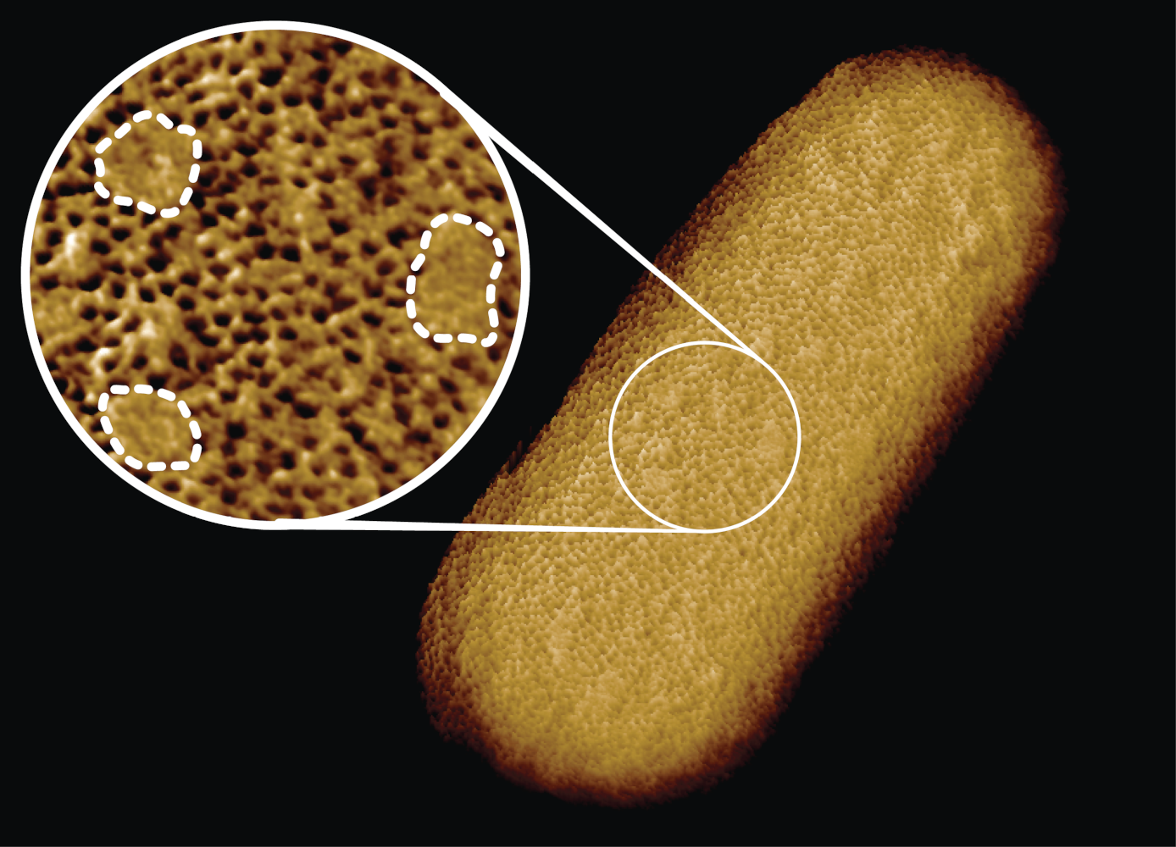
Not surprisingly, our immune system has found ways to overcome or perforate this barrier. E.g., when Gram-negative bacteria enter the blood stream, they are attacked by proteins that can self-assemble into large (~10 nm) oligomeric pores in the outer membrane. We have used atomic force microscopy to visualise how this self assembly occurs in real time, and found that its kinetics is tuned such that it gives our own cells a maximum temporal window to intervene, thus preventing the immune system from causing self-harm.
During such experiments on living E. coli, it has also become clear that the outer membrane is a quite exceptional membrane for biological standards. Specifically, we have found that this membrane is phase-separated into, on one hand, relatively static networks of transmembrane proteins, and, one the other hand, protein-depleted and lipid-enriched nano-domains. Some of these domains turn out to act as chinks in the armour of E. coli, making it vulnerable to harsh environments and to antibiotics that otherwise would only target Gram-positive bacteria (which do not possess an outer membrane).
These studies illustrate the beauty of biomolecular self-assembly and organisation in medically relevant contexts, and also raise intriguing questions on how the material state of the outer membrane allows for bacterial growth and division, with a doubling time of only 20 minutes for E. coli under favourable conditions.
Join us for coffee starting 3:30 p.m. Refreshments will be served after the lecture.
For more information contact the host: Wouter Roos (w.h.roos@rug.nl)
Website: https://www.rug.nl/research/fse/colloquia/physics-colloquia

