GDBC Thesis Award 2025 Digital Business
Introduction
The importance of digitization in business has increased significantly in recent years. These developments build on existing themes such as Information Systems and e-commerce, but also contain more technological and methodological elements as data science, block chain and artificial intelligence.
Given the importance of this field, the Groningen Digital Business Centre (GBDC) has organized another Digital Business thesis award. This award is intended for graduate Master students of the University of Groningen who have written a thesis on a subject related to the field of “Digital Business”. The field of Digital Business is interpreted broadly. The subject can be related to all disciplines within business and management, including accounting, finance, HRM, innovation management, marketing, supply chain and operations. See here more info about a few awards last years:
- Blog 2021 and Movie 2021
- Blog 2022 and Movie 2022
- Blog 2023
Examples of thesis topics are for example (and certainly not exclusively)::
- Business applications of AI and Data science
- Business applications of robotics
- Advancements in AI, data science and digital technology relevant for business
- Digital strategy and digital transformation of organizations
- Data readiness of organizations
- Digitalisation and sustainability
- Smart industries
- Ethical and legal aspects of AI / Data science
- IoT applications in business
- Applications of robotics in organizations
- Online retail, digital multi-channel management
- Communication in digital business environments

- Context and objectives:
This thesis award is a continuation of the earlier Aart Bosman Award and is made possible by a donation from Dr. Gezinus Hidding (alumnus Faculty of Economics & Business, 1982). With the award, Dr. Hidding, now associate professor at Loyola University of Chicago, wants to thank his former tutor, Prof.dr. Aart Bosman (1930-2008). Prof. Bosman was a professor at the University of Groningen and a pioneer and founder of the field of Information Science in the Netherlands. As a continuation, the GDBC has adopted this initiative and it will be continued under the name Thesis Award Digital Business.
The thesis award was created to stimulate the attention of students in academic education for digital business. With the Digital Business Thesis Award, the GDBC wants to encourage students to choose thesis subjects in the field of digital business and encourage them to contribute to the solutions of digitally related business administration issues. With the Digital Business Thesis Award, the GDBC wants to show the broad possibilities and high quality of graduation projects in the field of Digital Business.
- The Thesis Award 2023
The thesis award is awarded annually. For the GDBC Digital Business Thesis Award of a specific year (e.g. 2023), the thesis must be completed in that year (2023) plus the half year after it (till summer 2024) and defended in that year or in the first half year of the next year (2024). In principle, three theses are nominated. Subsequently, these three students are invited to present their work at the GDBC conference in December. Ultimately, there is of course one winner and she / he receives the thesis prize and an amount of 2000 euros. There are also honourable second and third prizes, of 1000 and 500 euros.
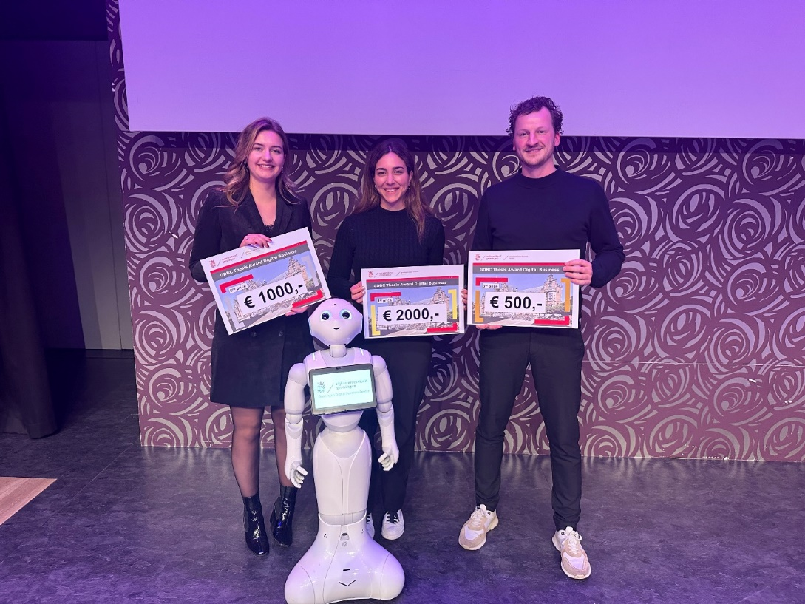
- Jury assessment
The jury for the award is organized by the GDBC. Jury members are appointed by the GDBC steering group. The jury is composed of people from the GDBC network and from scientific education in the field of digital business. The jury consists of three people. If a jury member is in any way involved in a submitted thesis (for example, in the nomination of a thesis or as an internship supervisor of a candidate), he will not participate in the assessment of this specific thesis. The jury decides which will be the three nominations and the final winner; by majority vote. The jury consists of the following persons:
- Representative of Entrepreneurs;
- Representative of Samenwerking Noord (SN);
- Director of GDBC (chairman of the jury), also part of FEB.
The jury uses the following assessment criteria (with weighting factor):
a) Topic (30%)
- Relevance to the practice of Digital Business,
- Scientific relevance of the subject within Digital Business,
- Originality.
b) Content (50%)
• Clear problem analysis and questioning,
• Good use of literature and theoretical foundation,
• Correct application of methods and techniques,
• Substantiated analysis and presentation of results,
• Substantiated conclusions,
• Relevant recommendations for practice and science.
c) Style and presentation (20%)
- Clear, good readable writing style,
- Good structure and structure of the thesis,
- Quality of the presentation during the event.
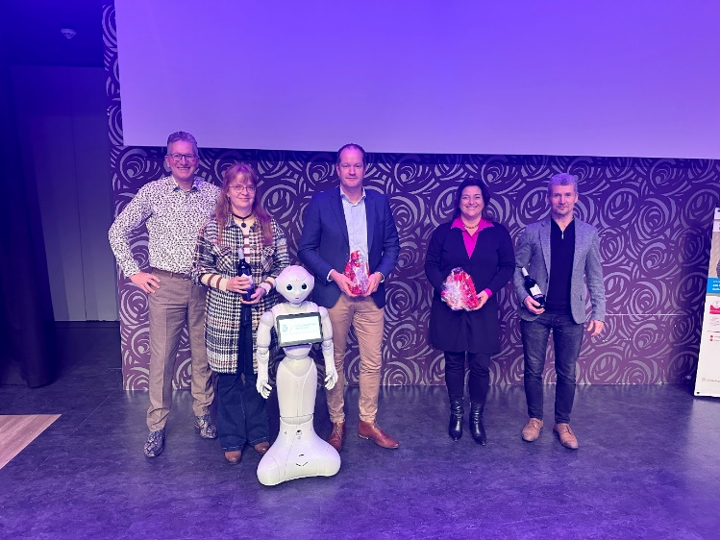

- Participation

- Participation in the thesis award is open to any recent or nearly graduated student at the University of Groningen (all faculties) who has successfully completed his or her master's thesis or graduation project in the period January 1 2025 till summer 2026.
- The closing date for the submission period is December 1 of the following year, so now 01-12-2026 for the 2025 thesis award.
- The student or graduate must send the thesis as a PDF file by e-mail to the GDBC: gdbc@rug.nl
The submission for the thesis prize must be accompanied by the following information:
- name, address, telephone number (s), e-mail address, date of birth of author
- faculty, name of the study program, title of the thesis, the grade with which the thesis was assessed and graduation date (intended)
- names, titles and e-mail address of the thesis supervisor (s).
Process
Action | Deadline | Actor
Communication towards students and study programs | Asap | GDBC / department of Communication FEB and other faculties, via study associations, education directors etc
Deadline hand-in thesis | December 1 2026 | Students and supervisors
Assessments submitted theses | December 2026 | Jury
Presentations and awards three prizes Thesis Award Digital Business 2025 | GDBC-Event in Medio December 2026 at Martiniplaza | All

