THE PHYSICS COLLOQUIUM
Thursday 31 March 2022, 4:00 p.m.
Bernoulliborg 5161.0253

Hairy nanoparticles:
a promising component for
impact-resistant polymer nanocomposites
Andrea Giuntoli
Zernike Institute for Advanced Materials

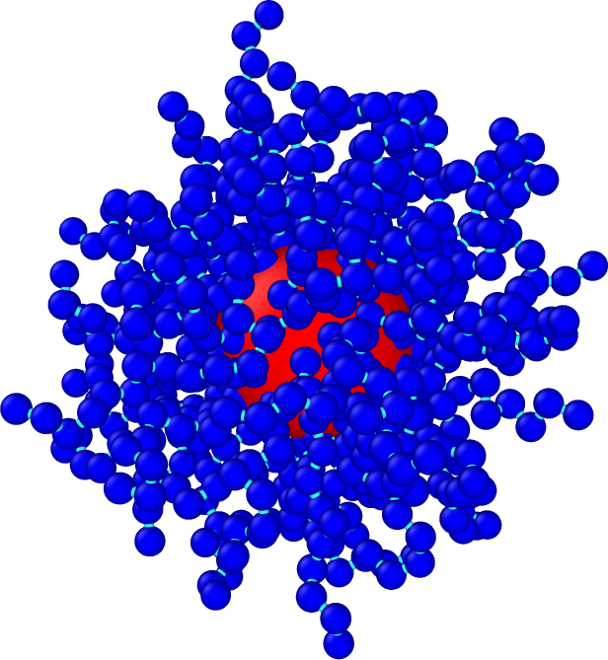
The introduction of elements like nanotubes or spheres in a polymer matrix can drastically change its properties. The resulting polymer nanocomposites are highly tunable, with a huge design space. Despite the obvious engineering applications, the fundamental physics of these systems is not at all trivial and touches upon the very definition of states of matter like liquids and solids.
I will discuss the case of nanoparticles grafted with polymer chains (a.k.a. hairy nanoparticles), the architecture of which can be tuned to control the dynamics, rheology, mechanical properties and energy dissipation of the resulting composite.
Taking a physicist point of view, I will first describe the fundamental relaxation phenomena that determine the macroscopic properties of these composites. I will then show recent applications in the field of impact-resistant thin films, where in the last few years a unique combination of theory, computer modeling and experiments is allowing the scientific community to quickly advance our understanding of these systems, from fundamental theory to engineering design.

To join online:
https://p2gonew.serverspace.rug.nl/P2G/Player/Player.aspx?id=5161-0253

