PHYSICS COLLOQUIUM
Thursday, 17 February 2022, 4:00 p.m.

Probing quantum properties
of van der Waals materials
Sense Jan van der Molen
(molen@physics.leidenuniv.nl)
Huygens-Kamerlingh Onnes Laboratorium, Universiteit Leiden, Netherlands

Van der Waals materials (vdW) are layered systems that can be exfoliated into atomically thin sheets, the most famous being graphite (yielding graphene). This opens up the possibility to stack different layers together, so as to build up novel materials in a LEGO-like fashion. The physics of vdW systems is rich and fascinating, depending strongly on the the interaction between the individual layers. Moreover, this interaction can be further tuned by twisting the layers with respect to each other [1,2]. A long-term dream of this research field is hence to learn how to pre-program the properties of novel artificial systems, thus creating ‘designer materials’.

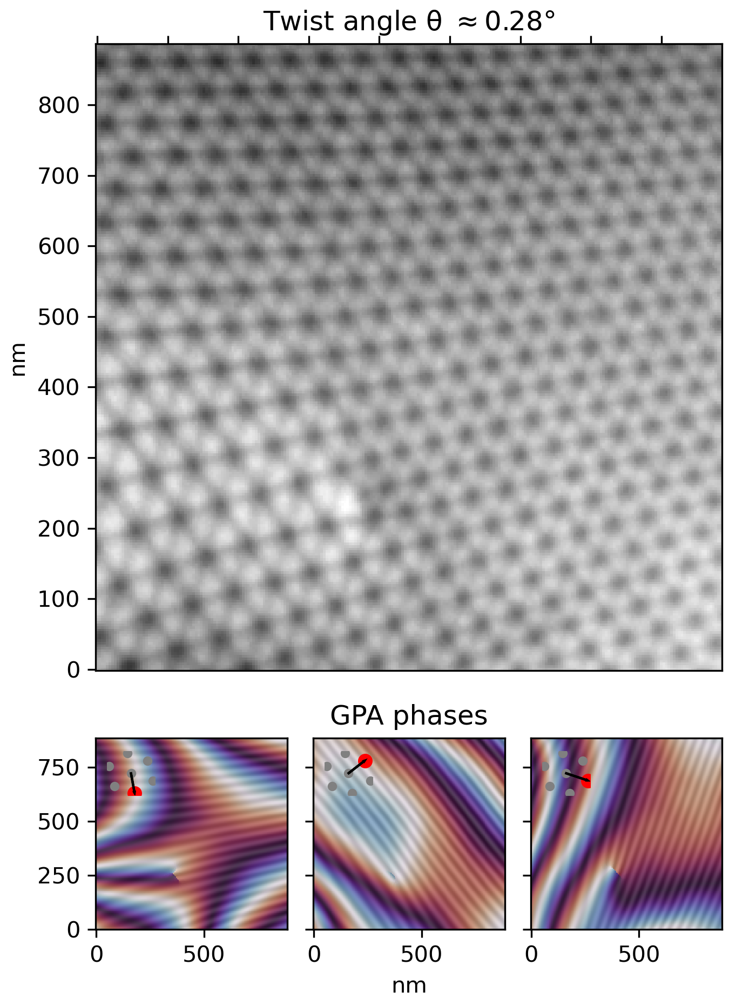
In this colloquium, I will discuss our recent work on vdW systems. We study these using the spectroscopic possibilities of low-energy electron microscopy (LEEM). Basically, we are able to locally determine the number of layers and their interaction at energies above the vacuum energy. Moreover, we can directly measure the dispersion relations of the unoccupied bands found, via a technique we called ARRES (angle-resolved reflected electron spectroscopy) [3,4]. After an introduction, featuring graphene and hBN, I will present and discuss recent data on so-called TMD systems (transition metal dicalchogenides), such as MoS2. Next, I will focus on twisted bilayer graphene, which becomes superconducting at a twist angle around 1.1o [1,2]. LEEM allows us to directly image the so-called moiré pattern that results from the twist. In Fig. 1 we give an example. Using spatial lock-in analysis, we can study the properties of these lattices in detail, and obtain (the variation of) the local twist angle. Moreover, with this method we can also pinpoint defects, such as the edge dislocation in Fig. 1. This atomic-scale (!) defect is visible in LEEM as a result of a magnification effect via the moiré pattern. Clearly, for optimal (superconducting) devices, defects and variation in twist angle are unwanted. Hence, I will end my talk by discussing a path towards homogenization [5].
Fig. 1 LEEM image of the moiré pattern of twisted bilayer graphene (θ=0.28º). A screw dislocation is seen within the ellips. This atomic-scale defect is visible due to the so-called moiré magnification effect.

[1] Y. Cao et al. Nature 556, 80-84 (2018)
[2] S. Lisi, T. Benschop, T. de Jong et al. Nature Physics 17, 189-193 (2021)
[3] Jobst et al., Nat. Comm. 6, 8926 (2015)
[4] Jobst et al., Nat. Comm. 7, 13621 (2016)
[5] De Jong et al. Nature Comm. 13, 70 (2022)

Link to online Physics colloquium:
https://p2gonew.serverspace.rug.nl/P2G/Player/Player.aspx?id=5161-0253

