  - Research report

The role of the T352P mutation in Shal/Kv4 transgenic Drosophila model for the human disease spinocerebellar ataxia type 19

Bioresearch
Irene Loppersum
21 May 2012
12-BR-10

  - Research report

The role of the T352P mutation in Shal/Kv4 transgenic Drosophila model for the human disease spinocerebellar ataxia type 19

Irene Loppersum
21 May 2013
12-BR-10
Hogeschool InHolland
Boelelaan 1109
1081 HV AMSTERDAM
Life Sciences, Research
Supervisor: Gert Jan Arts

Universitair Medisch Centrum Groningen, Department of Genetics
Hanzeplein 1
9700 RB GRONINGEN
Supervisor: Anna Duarri, Dineke Verbeek

Picture titlepage, Drosophila:
http://www.eisenlab.org/FunFly/wp-content/themes/zeebizzcard/images/default_header.jpg (Visited on 11-02-2012)
Samenvatting

Spinocerebellaire ataxie type 19 (SCA19) is een zeldzame vorm van ataxie die wordt veroorzaakt door atrofie van het cerebellum. De ziekte erft autosomaal dominant over en wordt gekenmerkt door langzame verslechtering van spraak, oogbewegingen en de manier van lopen en beweging van de handen. In 2001 is het ziekte locus voor SCA19 ontdekt, echter pas in 2011 werd de ziekte veroorzakende mutatie gevonden in het KCND3 gen. Het KCND3 gen codeert voor de voltage-gated kalium-kanaal, Kv4.3, de mutatie leidt tot een c.1054G>A; p.T352P verandering. In het SCA19 cerebellum van een patiënt met de T352P mutatie werd het verlies van Purkinje cellen, verandering van de lokalisatie van het Kv4.3 eiwit, lagere eiwit-expressie-niveaus en verlaagde kanaal activiteit aangetoond.
Dit project had als eerste doel het maken van transgene vliegen die de T352P mutant Shal tot expressie brengt en te karakteriseren. Het tweede doel was het bestuderen van het effect van Shal-T352P op oogdegeneratie van de vlieg, motor coördinatie en het ataxie fenotype. Het derde doel was het bestuderen van de neuronale overleving en het kanaal activiteit.
Transgene vliegen zijn gegenereerd die het Shal (wild type en T352P) transcript onder de UAS promotor dragen. Via specifieke GAL4-driver lijnen kan nu selectief het (wild type en T352P) ShaI tot expressie gebracht worden in ieder weefsel van interesse. Via een Da-Gal4 vliegen lijn werd het wild type en Shal-T352P tot over expressie gebracht in de gehele vlieg. De Shal-T352P/Da vliegen werden eerst gekarakteriseerd. Allereerst werd met q-PCR en Western blot geprobeerd de expressie van Shal-T352P aan te tonen. De ShaI expressie niveaus waren gelijk aan de wild type controles en middels Western blot was de expressie van Shal niet te zien. Echter toen Shal-T352P, tot expressie gebracht werd in het oog van de vlieg middels de driverlijn Gal4-GMR, bleek er op de Western blot expressie van Shal-T352P te zien. Helaas werd er geen oogdegeneratie geobserveerd. Door problemen met de levering van de UAS-Shal-wild type transgene vliegen zijn deze wel gebalanceerd en ingekruist met de Da en GMR driver lijnen, maar was er geen tijd voor verdere karakterisatie. Door materiaal en onverwachte problemen met de Gal4-Da driver lijnen zijn helaas niet alle experimenten uitgevoerd.
Summary

Spinocerebellar ataxia type 19 (SCA19) is a rare form of ataxia which is caused by atrophy of the cerebellum. SCA19 is an autosomal dominant disease and is characterized by slowly progressing ataxia, discoordination of balance, slurred speech, abnormal eye movements. In 2001 the responsible disease locus was discovered, however only in 2011 the disease causing mutation was discovered in this KCND3 leading to a c.1054G>A; p.T352P change. The KCND3 gene encodes for the voltage-gated potassium channel Kv4.3. Analysis of the cerebellum of a patient with the T352P mutation in Kv4.3 showed loss of Purkinje cells, change of localization of the Kv4.3 protein, lower protein expression levels and decreased channel activity.
This project had the first aim to create transgenic fly lines that express the Shal-T352P mutant and their characterization. The second aim was to study the effect of Shal-T352P on eye degeneration, motor coordination and ataxia phenotype in the fly. The third aim was the determine the effect of Shal-T352P on the neuronal survival and channel activity.
Transgenic flies were created that contain Shal (wild-type and T352P) under the UAS promoter. Using specific GAL4 driver lines enables the selective expression of Shal (wild-type and T352P) in any tissue of interest. With the Gal4-Da driver line, we expressed (wild-type and T352P) Shal in the whole fly. Then the Shal (wild-type and T352P)/Da flies were characterized. First the expression of the transgene was checked via q-PCR and Western blot. Unfortunately, the levels of the expression in Shal-T352P/Da flies was equal to its controls and no expression was detected via Western blot. In addition, when Shal (wild-type and T352P) was expressed using the GMR-Gal4 driver line generation Shal/GMR flies, we were able to detected expression of Shal-T352P, but no eye degeneration was observed.
Due to delivery problems of the stock UAS-Shal-wild type fly lines, these lines were only balanced and the crosses were set with the Da and GMR driver lines. Due to problems with the flies derived from the Da-driver lines not all experiments were performed.

Acknowledgement

First, I would like to express my great appreciation to Dr. Anna Duarri and Dr. Dineke Verbeek, for their patient guidance, help with my experiments and useful opinions of this research project. I also want to thank Bart Kanon for his help at the department of Cell Biology. Furthermore I want to thank Michiel Fokkens, Cleo Smeets, Esther Nibbeling, Melissa Boerrigter, Justyna Jezierska and Adrie Borremans for their company, help with my experiments and helpful tips. Finally, I want to thank Gert Jan Arts for his guidance during my project.

Table of contents

List of abbreviations 2
1. Introduction 3
1.1 Problem 3
1.2 Accountability 3
2. Theoretical context 4
2.1 Ataxia 4
2.2 Spinocerebellar ataxia type 19 4
2.3 KCND3, Kv4.3 and T352P mutation 4
2.4 Drosophila melanogaster 5
2.5 Balancer chromosome 7
2.6 GAL4/UAS system 7
3. Aims of this project 9
4. Materials and methods 10
4.1 Plasmids 10
4.2 Fly strains 10
4.3 Maintain, expanding and activation fly stocks 10
4.4 Balancing flies 11
4.5 Plasmid DNA and genomic DNA extraction 13
4.6 Cell culture and transfection 13
4.7 Protein extraction 13
4.8 RNA extraction from flies 14
4.9 Western blot analysis 14
4.10 Immunocytochemistry 14
4.11 PCR (polymerase chain reaction) analysis 15
5. Results 16
5.1.1 Plasmid testing 16
5.1.2 In vitro test of Shal-wt-FLAG and Shal-T352P-FLAG expression and localization in HeLa cells 16
5.2 Generation of transgenic fly line 18
5.3 Balancing UAS-ShaI-wt and T352P flies 18
5.3.1 Mapping 18
5.3.2 Genotyping 18
5.4 Activation of UAS-Shal-wt and T352P transgenic fly lines 19
5.4.1 Expression of T352P-ShaI transgenic lines using the Daughterless (Da) promoter. 19
5.4.2 Shal mRNA expression 20
5.4.3 Expression of Shal-wt and Shal-T352P mutant in the fly eye. 22
6. Discussion and conclusion 24
7. Literature list 26
Appendix I 29

List of abbreviations

BLAST - Basic Local Alignment Search Tool
CNS - Central neuron system
Cu - Curly
Da - Daughterless
DMEM - Dulbecco's Modified Eagle Medium
DNA - Deoxyribonucleic acid
Drosophila - Drosophila melanogaster
EDTA - Ethylenediaminetetraacetic acid
ER - Endoplasmatic reticulum
FBS - Fetal bovine serum
GFP - Green fluorescent protein
GMR - Glass multiple reporter
KChIPs - Kv channel interacting proteins
Kv4.3 - Potassium voltage-gated channel subfamily D member 3
LSB - Laemmli sample buffer
MCS - Multiple cloning site
PCR - Polymerase chain reaction
PEI - Polyethylenimine
RFP - Red fluorescent protein
SCA 19 - Spinocerebellar Ataxia type 19
SDS-PAGE - Sodium dodecyl sulfate polyacrylamide gel electrophoresis
Ser - Serreate
UAS - Upstream Activation Sequence

Introduction

Problem

“How does the spinocerebellar ataxia type 19 mutation T352P in Shal/Kv4 affect the correct channel function in neurons and how might the channel malfunction cause the SCA19 disease phenotype?”

Accountability

Spinocerebellar ataxia (SCA) is a rare neurodegenerative disease, hallmarked by atrophy of the cerebellum. There are 36 types of SCAs, but in only 20 types the malfunctioning genes are known. The disease is characterized by slowly progressive discoordination of gait, hands, speech and eye movement. SCA19 (spinocerebellar ataxia type 19) occurs predominantly in older people, most symptoms arise around the age of 40. This disease is autosomal dominant, which means that only one mutated copy of the gene is necessary to obtain the disease [1, 2].

In 2002 the SCA19 locus was mapped to chromosome 1 in a large Dutch family using linkage analysis. The locus is located in the chromosomal region 1p21-q21 [3]. In 2011, exome sequencing was performed on two affected members in this family. A novel missense mutation was found that lead to a c.1054G>A; p. T352P change in the KCND3 gene encoding for the voltage-gated potassium channel Kv4.3. Autopsy on the cerebellar material with the mutation showed severe atrophy of Purkinje cells [4].

Immunohistochemistry was done on the SCA19 cerebellum with T352P mutation in Kv4.3. It showed change of localization of the Kv4.3 protein in the cell and the protein expression levels of Kv4.3 were decreased. The mutant channel also showed endoplasmatic reticulum retention and lower protein stability in transfected HeLa cells. Co-expression together with the regulatory β-subunit KChIP2 caused the T352P mutant to localize correctly to the plasma membrane. Afterwards, potassium current were measured using single cell patch-clamp experiment to test the functionality of the channel showed that the activity of the Kv4.3 T352P-KChIP2 complex was strongly reduced [4]. How the mutant Kv4.3 lead to neurodegeneration is not known. Therefore, to reveal this, a transgenic fly model will be generated that mimics SCA19.

The main aim of this project is to unravel the effects of the T352P mutation on the Shal/Kv4 potassium channel function, neuronal cell survival and on the motor coordination alterations using a transgenic Drosophila model.
- The first objective is to generate a Drosophila model which expresses wild type and SCA19 mutant Shal in the whole body, eyes and brain/CNS (central neural system).
- The second aim is the characterization of locomotion and rhythmic behavior changes in Shal/Kv4-T352P transgenic flies.
- The third aim is to test the effect of the T352P mutant on the Shal/Kv4 potassium currents in vivo.

Defects in ion channels seem a common mechanism underlying many of the SCA types, like SCA6 [5] and SCA13 [6] and highlight the importance of identifying new disease-related genes that can advance the understanding of the disease etiology. The SCA19 Drosophila model will give an overview about the underlying disease pathology by elucidating the role of this specific mutation in the phenotype of the disease and may contribute the development of new therapeutic approaches for SCA-treatment.

Theoretical context

Ataxia

Ataxia is a neurological sign that consists of lack of coordination in muscle movement. There are two forms of ataxia: an acquired form and a hereditary form. While the acquired form is usually caused by external factors such as brain injury, a tumor or high alcohol levels: the hereditary form is passed down in families and shows a clear pattern of inheritance. The ataxia is a result of selective atrophy of the Purkinje cells in the cerebellum, granular cell layers and cerebellar nuclei [7, 8].

Spinocerebellar ataxia type 19

In 1993 the first SCA gene was identified, now there are 36 SCA types known, of which in only 19 types the disease causing gene has been identified [9, 10]. The types differ in the condition of the symptoms, some genetic causes are listed in appendix I. SCA19 is a rare hereditary form of ataxia [11]. This neurodegenerative disorder is manifested as a mild ataxia syndrome with loss of balance, cognitive impairment, low scores on the Wisconsin Card Sorting Test measuring executive function, myoclonus and postural tremor and additional characteristic symptoms [3, 11]. The mean age of getting clinical features is about 30-40 years, but there are some patients in families that show symptoms at age of 10 and 28 [1, 2, 12]. In 2001 the locus of SCA19 was identified on chromosome 1p21-q21 [2, 3]. This region was the same locus as for SCA22, which was identified in a large Chinese family [13]. It is suspected that SCA19 and SCA22 are the same condition. When comparing the clinical symptoms, SCA22 does not cause myoclonus and cognitive changes. So it is not completely clear if these two types are the same disease [2]. Hypothetically, due to the background of the families, the symptoms can be different.

KCND3, Kv4.3 and T352P mutation

In a last attempt to identify the disease gene, exome sequencing was done in two affected SCA19 family members in 2011 and a novel missense mutation in the KCND3 gene was identified that led to a c.1054A>C; p.T352P change [3]. This mutation changes the highly conserved threonine into proline in the Kv4.3 (potassium voltage-gated channel subfamily D member 3) channel. The T352P mutation in Kv4.3 is located in the pore loop of the protein [4].

Kv4.3 is a voltage-gated potassium (K⁺) channel, that is involved in the transient outward A-type K⁺ current in neurons [4]. It is expressed in the heart, brain and smooth muscles. In Drosophila four sequence-related K+ channel genes have been identified, named shaker, shaw, shab and shal. Each of these genes has a human homolog [14]. The Shal-type family in mammals is comprised of three distinct genes, KCND1 (Kv4.1), KCND2 (Kv4.2) and KCND3 (Kv4.3). The proteins encoded by these genes are highly homologue within the transmembrane regions, with divergent amino and carboxyl termini.

The protein structure comprises an intracellular N-terminal and C-terminal ends, and six transmembrane domains. The fourth transmembrane domain is a voltage sensor domain and transmembrane domains 5 and 6, together with the pore loop, forms the ion-selective pore (figure 1) [4]. The Kv4.3 channels consist of four functional or α-subunit contributing to the potassium pore formation. The channel is a transmembrane protein that is specific for potassium and sensitive to voltage changes in the membrane potential of the cell membrane. It underlies the repolarisation phase of the action potential to bring the cell into a resting state [15].

Figure 1: Schematic view of Kv4.3 in the membrane [11].
Kv4.3 has six transmembrane domains, a voltage sensor, a ion-selective pore and a N-terminal and C-terminal end.

The channel complexes are formed by different regulatory subunits and auxiliary subunits. The regulatory subunits influence expression and the function of K⁺ channels [16]. KChIPs (Kv channel interacting proteins) also help Kv4 pore-forming α-subunits to form a native complex in the brain and heart. They regulate the expression and gating properties of Kv4 K⁺ channels by interacting with the cytoplasmic N-termini of Kv4 family [17, 18].

Drosophila melanogaster

Drosophila melanogaster (Drosophila), better known as the fruit fly, is one of the most studied organisms in biology. In research of higher eukaryotes, including humans, Drosophila is used as a model for developmental and cellular processes. The genome of Drosophila contains 13.600 genes, spread over 4 pairs of chromosomes, one pair of sex chromosomes and three pair autosome chromosomes named 2, 3 and 4. The fourth chromosome is so small that it usually is ignored [19]. 50-70% mammalian genes are homolog to the Drosophila genes [14].

Normally Drosophila flies have red eyes, this can differ when working with transgene flies. Then the wild type flies can have white eyes, because they carry the w¹¹¹⁸ allele. Transgenic Drosophila flies carry the white+ allele together with their T352P mutation in a heterozygous state, leading to a red-eyes phenotype (figure 2) [20]. When crossing heterozygous flies together (+/- x +/-), the offspring will have red eyes when they contain the T352P mutation and white eyes when they do not have the mutation. The white-eyed flies can be used as controls in experiments.
Figure 2: Eye phenotypes of the white gene in Drosophila [17].
The wild type Shal and mutant Shal contains a white+ allele and is denoted by + .

The flies are yellow-brown in colour and have black rings across their abdomen. Females are approximately 2.5 mm long and the males are a bit smaller. The back of the males bodies are slightly darker. The females have a more pointy back and the males more round [19]. The virgin females can be recognised because they have a black spot on their belly (meconium), which is the food they ate before they went in the pupa stage (figure 3).

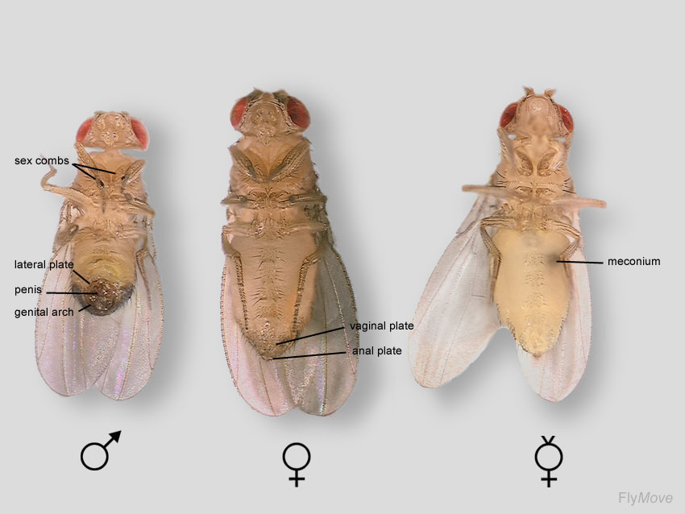
Figure 3: Male, female and virgin female Drosophila
The males (left) have a round back and the females (middle) a more pointy back. The virgin female (right) is recognizable by the black spot on their belly.
Source: http://www.stolaf.edu/people/colee/studentprojects/drosophila/Emily%20Landon%20drosophila%20project/graphics/MaleFemaleTafel.jpg (14-02-2013)

The life cycle of Drosophila is dependent on the temperature. The ideal development time is 8.5 days and is achieved at a temperature of 25 ˚C. The shortest development time is 7 days at 28 ˚C. At higher and lower temperatures it takes longer to develop (11 days at 30 ˚C) due to heat stress and hypothermia. Females lay around 400 eggs in rotten fruit or other decaying materials. At 25 ˚C after about 12 to 15 hours the larvae grow for 4 days and go through the 2nd- and 3rd-instar larvae stages (figure 4). Thereafter, the larvae pupate. Once encapsulated the larvae undergo a four day long metamorphosis after which the adult flies emerge [21]. Females become fertile about 8-12 hours after emergence [22]. Males have around the genitals a group of prickly hairs (barbs) they use to hook themselves to the female during mating [23]. Flies are ideal for genetic studies, because they are small, easily to maintain, they reproduce rapidly, have a large number of offspring and especially because of the different phenotypes, like colour and shape of the eyes and shape of the wings.

Figure 4: Life cycle of Drosophila [20].
The life cycle of Drosophila is 8-9 days at 25 ˚C. In this period, several stages are passed.

Balancer chromosome

The balancer chromosome is a genetic tool to prevent crossing over between homologous chromosomes during the meiosis. These chromosomes are specially modified to use for genetically screening a population of organisms, in this case Drosophila, to select for heterozygotes. Balancer chromosomes have a build in chromosomal inversions so the homologous chromosomes are not equally paired (figure 5) [24]. Using these balancers is to map the transgene and for not losing the transgene due recombination events during crosses.

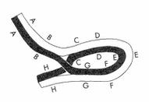

Figure 5: The effect of a balancer chromosome.
By the inversion in the balancer chromosome (black) it is no longer associated with the same homologous chromosome (white).
Source: http://1.bp.blogspot.com/_DZH2cmCoois/SPeZytXRN0I/AAAAAAAAGFU/pCO0dYGkVZQ/s400/tmp.jpg (18-02-2013)

Balancer chromosomes suppress recombination with their homologs, carry dominant markers and negatively affect reproductive fitness when carried homozygous. A dominant marker which is used is, for example, the gene Curly (Cu). These flies have curly wings. Another gene is Serreate (Ser) which causes the flies to have notched wings. The offspring that carries the balancer chromosomes are easily recognized by their phenotype [24].

GAL4/UAS system

The GAL4/UAS system is a method to study gene expression and function, in this case, in the fruit fly. The system contains two parts: the driver lines which contain the GAL4 gene (encoding the yeast transcription activator protein Gal4) and the reporter lines which contain the UAS (Upstream Activation Sequence), an enhancer to which Gal4 specifically binds to activate gene transcription [25].

Different GAL4 driver lines are developed in Drosophila with a promoter gene (genomic enhancer) so GAL4 can be expressed in specific fly tissues. For example the Glass multiple reporter (GMR) which is expressed only in the eye [26] and the daughterless gene (Da) which is a nuclear protein that is expressed throughout the fly during development [27]. Also different UAS reporter lines are developed, which are fly lines with special UAS region next to a desired gene. This is often GFP (Green fluorescent protein), RFP (Red fluorescent protein) or a channel rhodopsin (it allows light sensitive triggering of nerve cells). The insertion of the UAS-gene construct is done randomly. To deal with this, flies are mapped and the transgene is sequenced to see if there are no genes are interfered. The transgene is present in all cells although it is not expressed, because there is no GAL4 protein present. When the flies of the GAL4 driver line are crossed with the UAS reporter line the offspring of these flies will have the GAL4/UAS construct which the gene will be expressed (figure 6) [28] [29].

Figure 6: GAL4/UAS system [25].
The GAL4 driver line is crossed with a UAS reporter line that contains a human gene. In the offspring the UAS region is activated by the GAL4 protein which ensures the transcription of the human gene.

Aims of this project

The main goal of the project is to create a transgenic Drosophila model that mimics the human SCA19 disease. This in vivo model will allow us to study the effects of the T352P mutation on the Shal/Kv4 potassium channel function, neuronal cell survival and motor coordination alterations.

Initially, the project consisted of three aims:
- The characterization of the SCA19 fly model by studying localization and expression of the Shal1-T352P mutant channel complexes;
- The characterization of loco motor and rhythmic behaviour changes in the Shal/Kv4-T352P transgenic flies;
- Test the effect of the T352P mutant Shal channel on the Shal/Kv4 wild type potassium currents in vivo.

Due to the lack of time, we reconsidered the aims of the project accordingly to be:
- Study the cellular localization and protein expression of Shal-wt-FLAG and Shal-T352P-FLAG mutants plasmids used to generate the transgenic fly lines.
- Balance the Shal1-wt and Shal1-T352P fly lines and determine the location of the inserts in the fly genome.
- Characterization of the Shal1-wt and Shal1-T352P fly lines using different specific cell type promoters.

Materials and methods

Plasmids

The Shal-wt-FLAG, Shal-T352P-FLAG, Kv4.3 wt-FLAG and Kv4.3-T352P-FLAG constructs in pcDNA3 plasmid were used for expression in mammalian systems (HeLa cells). Shal-wt-FLAG and Shal-T352P-FLAG constructs in pUAST-Gal4 system were used to generate transgenic flies. The FLAG-tag enabled us to distinguish between the endogenous Shal from the transgenic wild type and T352P mutant Shal.

Fly strains

Table I shows the fly lines that were used in this study. The names of the flies are given, the genetic background, eye color of the flies, wing shaping and what the flies are used for.

Table I: Fly lines
Name fly line | Genetic background | Eye color | Wings | Used for
Balancer 2 | Sco/CyO | White | Curly | Balancing and wt control
Balancer 3 | PrDr/TM3,st | White | Notched | Balancing and wt control
Double Balancer | TM6,Tb/TM3,Ser | White | Straight | Wt control
Shal1-wt | Shal1-wt/+ | Red | Straight | Transgenic
Shal1-T352P | Shal1-T352P/+ | Red | Straight | Transgenic
Shal1-wt w1118 | +/+ | White | Straight | Control for transgenic
Shal1-T352P w1118 | +/+ | White | Straight | Control for transgenic
Shal1-wt Balanced | Shal1-wt/+  Shal1-wt/CyO  Shal1-wt/TM3,st | Red | Straight and  curly or notched | Stable balanced transgenic
Shal1-T352P Balanced | Shal1-T352P/+  Shal1-T352P/CyO  Shal1-T352P/TM3,st | Red | Straight and  curly or notched | Stable balanced transgenic
Da (#8641) | GAL4-Da/+ | White | Straight | Whole body driver
GMR (#1104) | GAL4-GMR/Cyo | Red | Straight | Eye driver
ELAV (#8765) | GAL4-ELAV/Cyo | White | Straight | CNS driver

Maintain, expanding and activation fly stocks

The flies were kept in tubes with Bloomington Drosophila medium with yeast on top. Once every two weeks, medium was refreshed. Tubes with fly stocks were kept at room temperature.

Expanding of flies was done as follows. Three males of a UAS reporter line were crossed with three virgin females of the GAL4 driver line. The tubes were incubated at 25 ˚C. After 5 days the parents were removed from the tube and after 10 days the first flies hatched. Virgin flies were collected immediately after hatching for further crosses. Flies for further experiments were collected any time.

We were working with 8 different lines for UAS-Shal-T352P (Shal mutant p. T352P) and another 8 lines for UAS-Shal-wt (wild type). The lines were made in eightfold, so we could make a selection which flies had an equal expression. These lines contain the Shal1-FLAG transgene but are not active. To make the transgene lines active the UAS lines were crossed with GAL4-Da/+ (expression in the whole body), GAL4-GMR/Cyo (expression only in the eye) and GAL4-ELAV/Cyo (expression in the CNS). The UAS lines were developed and ordered at BestGene Inc (Chino Hills, CA, USA). The GAL4 lines were available at the department of cell biology.

Balancing flies

The process of balancing flies starts with collecting virgins of the balancer chromosomes. Balancer chromosome 2 contains the Cu gene, recognized by the curly wings. Balancer chromosome 3 contains the Tm3, Ser gene was recognized by the stubble hairs and notched wings (figure 7B). The balancer flies had white eyes (figure 7A). The balancer virgins were crossed with the males of the UAS-Shal1-wt line and UAS-Shal1-T352P line. This line has always red eyes (figure 7A). Since it is not known on which chromosome the transgene is located, both chromosome 2 and chromosome 3 are balanced. Chromosome 4 is so small, that chances for transgene integration are limited, and was ignored for balancing. The X chromosome was not used for balancing because only the females carry the balanced chromosome. The offspring of the balanced cross can have four variants. Flies with red eyes and straight wings, red eyes and curly wings or stubble hairs, white eyes and straight wings and white eyes with curly wings of stubble hairs (figure 7C). The flies with red eyes and curly wings or stubble hairs were collected and the virgin females and the males of the same phenotype were crossed together. This is necessary to map the inserted gene of the UAS-Shal line. When the offspring of the second cross of balancer 2 contains only red eyes then the gene is on the second chromosome. When the offspring is mixed with white and red eyes, the gene will be on the third chromosome. The same strategy applies for balancer 3. Both balancers are performed in parallel (figure 7D).

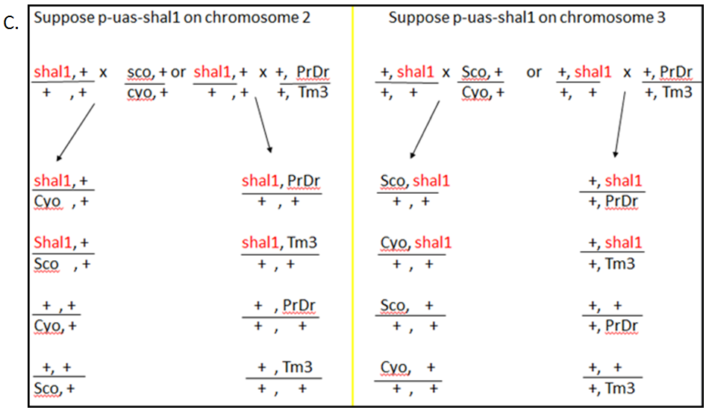
Figure 7: Balancing of the UAS-Shal1 driver line.
A. The eye phenotypes of the UAS-Shal1 (red eyes) and the balancer lines (white eyes). B. Phenotypes of the normal chromosomes and the balancer chromosomes. C. First balancing cross. The Shal1 flies are crossed with the balancer lines. Flies with red eyes and curly wings or red eyes with stubble hairs are collected. D. Second balancing cross. The collected flies are crossed with each other to map where the Shal1 gene is localized. If the offspring with the balancer chromosome 2 contains only red eyes, it means that the Shal1 gene is on the second chromosome. When the offspring have red and white eyes it means the Shal1 gene is localized on the third chromosome.

Plasmid DNA and genomic DNA extraction

E.coli DH5α strain from stored glycerol stock was cultured in LB medium containing antibiotics. It was grown overnight at 37˚C in a shaking incubator. For the isolation of DNA, the GeneJET Plasmid Miniprep Kit (Thermo Scientific, Rockford, USA) kit was used according to the manual.

For extraction of genomic DNA, flies were collected, snap frozen in liquid nitrogen, grinded and incubated overnight in 495 µl 1x SE (75 mM NaCl, 24 mM EDTA (Ethylenediaminetetraacetic acid), pH 8.0), 50 µl 10% SDS and 5 µl proteinase K (Roche, Indianapolis, USA) at 55 ˚C. The solution was mixed and added 200 µl 6M NaCl and 770 µl chloroform. Next, the mixture was centrifuged for 10 minutes, at 12000 rpm at room temperature. The upper layer of the solution was transferred to a new tube and 500 µl iso-propanol was added. The mixture was mixed by hand and centrifuged at 12000 rpm at 4 ˚C for 10 minutes. Supernatant was discarded and the pellet was washed with 250 µl cold ethanol (70%), centrifuged at 12000 rpm at 4 ˚C for 10 minutes. The supernatant was discarded, the pellet was air dried for 20 minutes and dissolved in 25 µl dH₂O. DNA concentrations were quantified by NanoDrop 1000.

Cell culture and transfection

HeLa cells were grown in DMEM (Dulbecco's Modified Eagle Medium) (Invitrogen, Carlsbad, CA, USA) with 10% FBS (Fetal bovine serum) and 1% of Pen/Strep (Gibco, Rockville, MD, USA) and incubated at 37 ˚C with 5% CO2. Cells for Western blot were grown in 6-well plates and cells for immunocytochemistry were grown on 12-well plates with cover slips (12 mm), after 24 hours followed a transfection with PEI (Polyethylenimine) (Polysciences Inc., Warrington, PA, USA). For a 24 well/plate, 0.5 µg of DNA, 2.5 µl PEI (1 mg/ml) and 50 µl DMEM are used per well. For a 6 well/plate, 1 µg DNA, 5 µl PEI (1 mg/ml) and 150 µl DMEM are used per well. The mixtures were incubated for 15 minutes at room temperature and then added to the wells. The transfection was incubated for 48 hours on 37 ˚C with 5% CO2.

Protein extraction

After the transfection that was incubated for 48 hours, medium was removed and cells were washed with PBS (Phosphate buffered saline). Then 150 µl lysis buffer (2% SDS in PBS with protease inhibitor cocktail 25x (Roche Diagnostics, Indianapolis, USA)) was added to the wells. The cells were scraped and collected in a tube. Next, the cells were sonicated to disrupt the cell membranes and the genomic DNA. Proteins were quantified using Pierce BCA Protein Assay kit (Thermo Fisher Scientific Inc., Rockford, USA) according to the manual. Next LSB 4x (Laemmli sample buffer 4x (125 mM Tris-HCl, pH 6.8, 8% SDS, 40% glycerol, 0,008% bromophenol blue) with 10% β-ME (β-mercaptoethanol) was added to the samples and they were heated at 65 ˚C for 5 minutes. Samples were then ready to use for Western blotting.

For protein extraction from flies, 6 flies (males and females together) or 15 fly heads were snap frozen in liquid nitrogen for 5 seconds. 50 µl laemmli buffer (125 mM Tris-HCl, pH 6.8, 8% SDS, 40% glycerol and without bromophenol blue) was added to the flies and the mixture was grinded with the polytron and then sonicated 4-5 times for 5 seconds. Then more laemmli buffer was added in a total volume 100 µl. Proteins were quantified using Pierce BCA Protein Assay Kit and 10% β-ME and 0.008% bromophenol blue were added to the samples. Samples were heated at 65 ˚C for 5 minutes. Except the head samples that have to be tested for Rhodopsin.

RNA extraction from flies

Flies or fly-tissue (50 mg) was snap frozen in liquid nitrogen for 5 seconds and grinded into powder. 1 mL of TRIzol (Ambion® Life Technologies, Bleiswijk, NL) was added and mixed. The mixture was incubated for 5 minutes and centrifuged to pellet insoluble debris, like the exoskeleton, at 12.000 rcf at 4 ˚C for 10 minutes. Next, the supernatant was transferred to a new tube and 200 µl chloroform was added. Tubes are shaken vigorously by hand and incubated at room temperature for 3 minutes. Then the samples were centrifuged at 10.000 rcf at 4 ˚C for 15 minutes. The water phase was transferred to a new tube and 500 µl iso-propanol was added to pellet the RNA. It was mixed and centrifuged at 12.000 rcf at 4 ˚C for 10 minutes. The supernatant was discarded and the pellet was washed with 1 mL 75% ethanol, centrifuged at 7.500 rcf at 4 ˚C for 5 minutes and the supernatant was discarded. The pellet was air dried for 10 minutes and dissolved in 100 µl RNase-free water. RNA was quantified with NanoDrop 1000.

Western blot analysis

For the SDS-PAGE, 10% Acrylamide gels were prepared so that the Kv4.3 and Shal (70 KDa) proteins, actin (45 KDa) and Rhodopsin (30 KDa) separated well. 15 combs (1.5 mm) were used. 25 µg or 50 µg protein sample and 4 µl protein marker were loaded on the gel and was run in running buffer (1x Tris-Glycine, 0.1% SDS) at 100V through the stacking gel and 120V through the running gel. Nitrocellulose membranes were incubated in transfer buffer (1x Tris-Glycine, 20% methanol) for 5 minutes and the sandwich was mounted and put in the transfer cassette together with an ice cube and cold transfer buffer. The blotting occurred at 250 mA for 90 minutes. To check if the blotting succeeded, the membrane was stained with Ponceau S (Ponceau red). Ponceau S stains the proteins and provides a rapid way to visualize the proteins on the membrane. After checking if the transference worked, the membrane was washed with transfer buffer and blocked with 5% milk-TTBS (Tris bufferd saline, 0.05% Tween 20) for 1 hour at room temperature or o/n at 4 ˚C shaking. The membrane was incubated with the primary antibody (see table II) in 5% milk-TTBS for 1 hour at room temperature or overnight at 4 ˚C shaking. Then the membrane was washed three times for 10 minutes with TTBS and incubate with the HRP-conjugated (horseradish peroxidase) secondary antibody, 1:10.000 (α-mouse (Sigma)) in 5% milk-TTBS for 1 hour at room temperature in the shaker. Next, the membrane was washed three times for 10 minutes with TTBS and incubated with ECL (Enhanced chemiluminescence) (homemade: for 50ml: solution A -> 5 ml 1M Tris pH 8.5, 45 ml water, 110 µl of coumaric acid 90mM and 250 µl luminol 250mM and for 1 ml of solution B -> 900 µl of water and 100 µl of hydrogen peroxide 30%). These were mixed as follows: 1 ml of Sol A with 15 µl sol B for one membrane) was used to develop the membranes during one minute and the excess of ECL was removed afterwards [30].

Table II: Primary antibodies for western blot and immunocytochemistry
Antibody | Company | Dilution
Anti-FLAG | Sigma | 1:500
Anti-Rhodopsin 4C5 | Developmental Studies Hybridoma Bank | 1:1000
Anti-actin | Sigma | 1:5000

Immunocytochemistry

After transfection that was incubated for 48 hours, medium was removed and cells were washed with PBS. For fixing the cells 4% PFA (paraformaldehyde) was used for 15 minutes at room temperature and the samples were washed three times with PBS. To permeabilize the cells, they were incubated with 0.1% triton-PBS for 10 minutes at room temperature. The cells were blocked with 5% BSA-PBS for 30 minutes at room temperature and incubated with the primary antibody (see table I) in 5% BSA-PBS for 1 hour at room temperature or overnight at 4˚C. For using a minimum of antibody, one drop (35 µl) of antibody is used with the coverslip face down the cells in a humid chamber. The coverslips were placed back in the wells and washed three times for 10 minutes with PBS. Next, the secondary fluorescent antibody (Cy3, 1:5000) was incubated in 5% BSA-PBS (200 µl/well in a 24 well/plate) for 1 hour at room temperature in the dark. Then, the cells were washed three times 10 minutes with PBS. Finally, the coverslips were mounted on the slides with Vectashield® Mounting Medium with DAPI (Vector Laboratories, Inc., Burlingame, CA, USA) and checked with a fluorescent microscope.

PCR (polymerase chain reaction) analysis

To directly sequence genomic DNA, 8 µg genomic DNA was vortexed 1 minute at maximum speed, then it was denatured for 10 minutes at 95 ˚C and cooled on ice, 40 pmol primer (3P-element F and 5P-element R) (Table IV) and 6 µl BigDye® Terminator (Applied Biosystems) were added to the DNA. The PCR program is shown in table III. Step 2-4 were repeated 99 times. Then, the mixture was washed with 70% ethanol and sequenced by sanger sequencing.

Table III: PCR program for sequencing
Step 1 | 95 ˚C | 5 minutes
Step 2 | 95 ˚C | 30 seconds | 99x
Step 3 | 60 ˚C | 30 seconds
Step 4 | 60 ˚C | 4 minutes
Step 5 | 4 ˚C | ∞

Table IV: Overview primers.
Primer | Sequence
dShal1 Forward | GGACGAGGACATCTTCGAGCT
dShal1-Flag Reverse | GATTACAAGGATGACGATGACAAG
dShal1 Reverse | GTAGCGCTGGGAGCAGCATC
3P-element Forward | ACTCGCACTTATTGCAAGCATACG
5P-element Reverse | TCTCAACAAGCAAACGTGCACTGA

For the normal PCR 2.5x AmpliTaq Gold® Fast PCR Master Mix (Applied Biosystems), 10 ng-1 µg DNA, 10 µM primer mix (see table IV) and 1 M betaine were mixed. The PCR program is shown in Table V.

Table V: PCR program for amplification
Step 1 | 95 ˚C | 3 minutes
Step 2 | 95 ˚C | 30 seconds | 34 x
Step 3 | 58 ˚C | 30 seconds
Step 4 | 72 ˚C | 45 seconds
Step 5 | 72 ˚C | 4 minutes
Step 6 | 4 ˚C | ∞

Results

Plasmid testing

For the generation of transgenic fly lines, two constructs were made and sent to BestGene Inc. (Chino Hills, CA, USA). The constructs were pUAST-Shal1-wt-FLAG and pUAST-Shal1-T352P-FLAG. The pUAST constructs contain P-elements that were used to insert Shal transgene in the fly genome randomly. The insertion also contains the white[+] gene that confers the red eyes to the transgenic flies. The Shal-wt-FLAG and Shal-T352P-FLAG were cloned in the multiple cloning sit (MCS) after the UAS (upstream activation sequence) (figure 8). The red arrows marked the primers which were used to genotype the insertion in section 5.3.2.
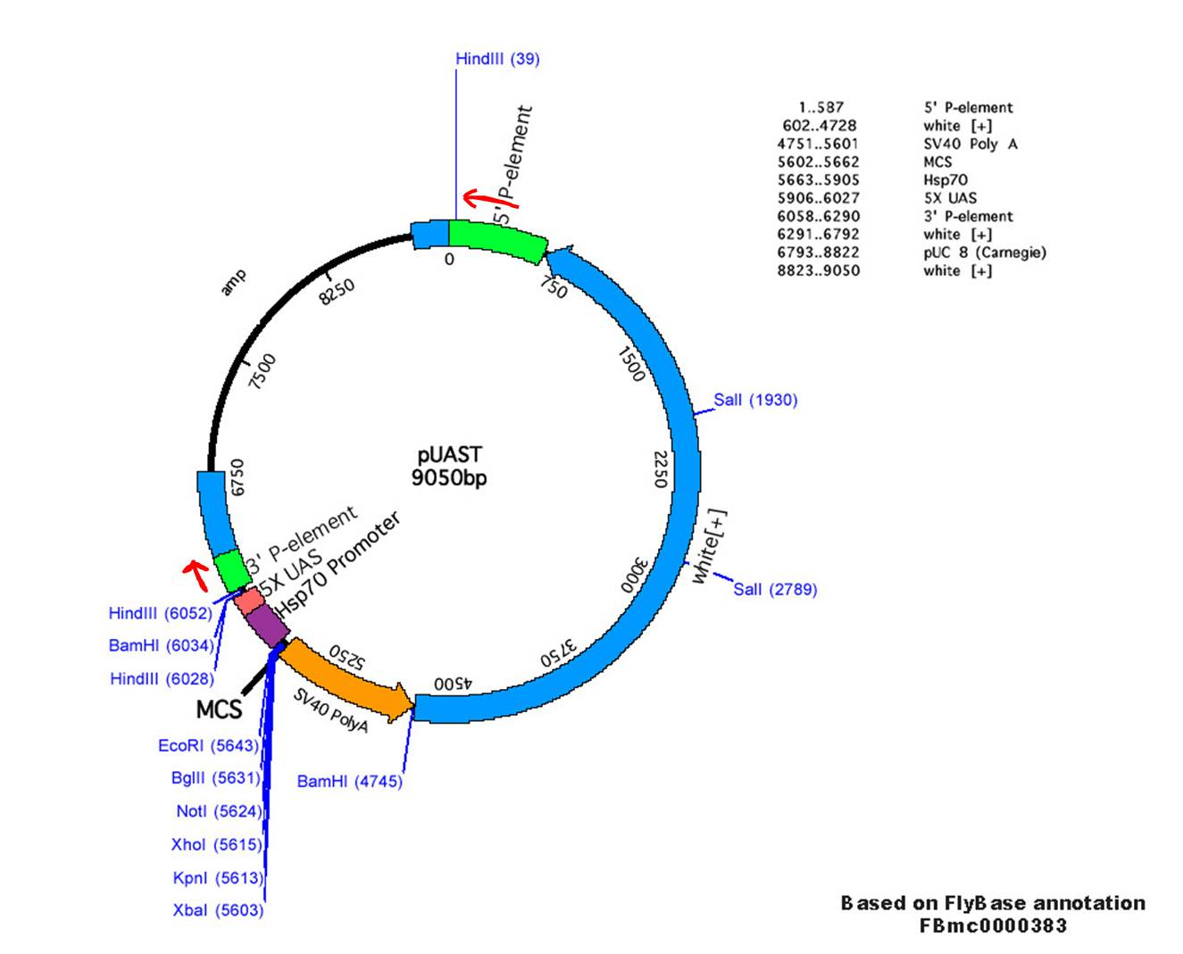
Figure 8: pUAST map. Shal-wt-FLAG and Shal-T352P-FLAG were cloned in the MCS after the UAS. The red arrows marks the primers which are used to genotype the insertion in the fly genome.

In vitro test of Shal-wt-FLAG and Shal-T352P-FLAG expression and localization in HeLa cells

In previous studies, human Kv4.3 carrying the T352P mutation showed retention in the endoplasmatic reticulum (ER) of HeLa cells. In order to prove that the T352P mutation in Shal caused the same effect, first immunocytochemistry was performed to study the localization of the Shal-T352P mutant in vitro. HeLa cells transfected with Shal-wt-FLAG showed clear plasma membrane localisation of wild type (wt) Kv4,3, whereas in contrast, cells transfected with Shal-T352P-FLAG showed the expected protein retention in the ER (figure 9).
Shal-T352P-FLAG
Shal-wt-FLAG
Figure 9: Localization of Shal-wt and Shal-T352P in Hella cells. HeLa cells were transfected with plasmids Shal-wt-FLAG and Shal-T352P-FLAG and were stained with anti-Flag primary antibody following by a secondary Cy3-conjugated, a fluorescent dye. The wild type (wt) shows mostly red staining in the plasma membrane. Shal-T352P-FLAG shows red staining intracellular which suggest the protein is located in the ER.

This result showed that the plasmids were well designed, and are able to express ShaI-wt or T352P with the Flag-tag in the C-terminus, and the T352P mutation induces also ER retention of Shal as had been seen for Kv.3 and thus confirmed previous findings.

To test for the protein expression of the Shal-wt-Flag and T352P mutant in transfected HeLa cells, protein extracts were loaded on an SDS page gel. Western blotting was used to detect the FLAG-tag using an anti-FLAG antibody. The Western blot is shown in figure 10. Untransfected cells were used as a negative control and cells transfected with human Kv4.3 wt-FLAG and T352P-FLAG mutant cDNA were used as a positive control. Kv4.3 gave a band at ~70 kDa. Monomeric Shal wt and Shal T352P have lower molecular weight (~60 kDa) compared to Kv4.3 (~70 kDa), but higher molecular weight complexes were detected. Around 70 kDa unspecific bands (arrow) were seen as this bans was also visible in the negative control.

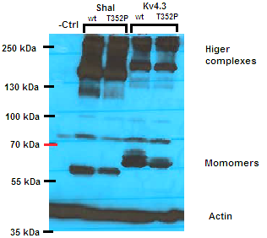
Monomers
Figure 10: Protein expression patterns of Shal-wt and T352P mutant and Kv4.3 wt and T352P mutant. HeLa cells were transfected and lysed, and 50 µg of protein loaded to perform the control western blot. Upper part was incubated with anti-Flag and the lower part with anti-actin antibodies. Actin is clearly visible at ~42 kDa and is used as a control. Monomers and the higher complexes of Shal and Kv4.3 were detected. Over 70 kDa shows an unspecific band marked with an arrow.

These data enabled us to detect Shal-wt and T352P protein expression by western blot using the anti-flag antibody.

Generation of transgenic fly line

We received 8 fly lines containing UAS-Shal-wt-FLAG and 8 fly lines with the UAS-Shal-T352P-FLAG transgene insertions from BestGene Inc. These flies were all heterozygous (UAS-Shal/+), had red eyes and contain an inactive transgene. As the stocks are heterozygous, during expansion of these lines, not all offspring carried red eyes. The white eyed (UAS-+/+) flies were used as a control for each individual line.

Balancing UAS-ShaI-wt and T352P flies

Mapping

To map the transgene insertion in every fly line, we crossed the heterozygous UAS-ShaI-wt/T352P lines with special balancer fly lines; Sco/CyO (Balancer for chromosome 2) and PrDr/Tm3,st (Balancer for chromosome 3) (see figure 6 in the material and methods). When the offspring hatched, red eyed virgin female flies with curly wings or notched wings were crossed with males from the same offspring with red eyes and curly wings or notched wings. The offspring of the second cross was observed. If the offspring that was balanced with the chromosome 2 balancer and contained only red eyes, we could conclude that the transgene was integrated in chromosome 2. If it contained white and red eyed flies, the transgene was integrated in chromosome 3. So, when the offspring crossed with the chromosome 3 balancer only had red eyes, the construct was integrated in chromosome 3 and when the offspring displayed white and red eyes, the transgene had to be integrated in chromosome 2. For each line, the two crosses with two different balancer fly lines were done to be sure in which chromosome the construct was integrated. Table V shows the chromosomal location of the transgene integration per fly line. Some crosses did not have a red eyed offspring so could not be balanced.

Table V: Mapped flies
Fly line | Chromosome | Fly line | Chromosome
Shal1-wt-1 | 3 | Shal1-T352P-1 | unknown
Shal1-wt-2 | 2 | Shal1-T352P-2 | 2
Shal1-wt-3 | 3 | Shal1-T352P-3 | 3
Shal1-wt-4 | 3 | Shal1-T352P-4 | 3
Shal1-wt-5 | 2 | Shal1-T352P-5 | unknown
Shal1-wt-6 | X | Shal1-T352P-6 | unknown
Shal1-wt-7 | 2 | Shal1-T352P-7 | unknown
Shal1-wt-8 | 2 | Shal1-T352P-8 | 3

Genotyping

To see where the UAS-Shal-wt-FLAG and UAS-Shal-T352P-FLAG transgene cassettes were integrated in the genome, Sanger sequencing of genomic fly DNA was done using specific primers for the flanking P-elements. In figure 10, two sequences are shown: Shal1-T352P line1 was sequenced using the reverse primer 5Pelement R (figure 11A) and Shal1-T352P-1 w1118 (white eyes, used as a control) using the forward primer 3Pelement F (figure 11B). We used BLAST (Basic Local Alignment Search Tool) to see were the transgenes were integrated and to identify if any known genes were located around the inserted transgenes. But the sequence peaks were short and double or triple peaks were observed. The sequences were unreadable and we were unable to determine the site of integration.
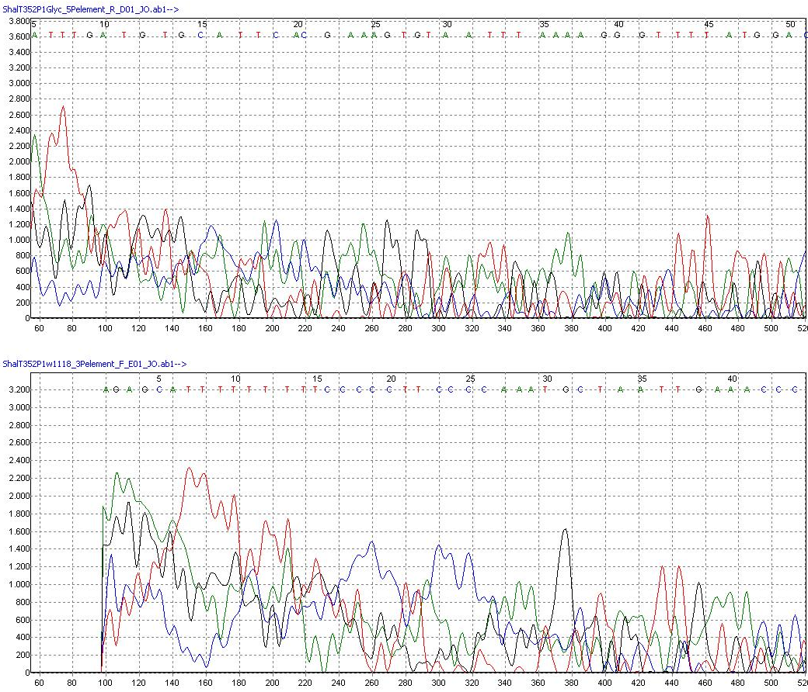
A
Figure 11: Genomic sequences of transgene lines. A: sequence of fly line shal1-T352P line1 with primer 5Pelement R. B: sequence of fly line Shal1T352P line1 w1118 (white eyes, used as a control) with primer 3Pelement F.
B

Activation of UAS-Shal-wt and T352P transgenic fly lines

Expression of T352P-ShaI transgenic lines using the Daughterless (Da) promoter.

To measure the expression of the wt and T352P-ShaI in the fly lines, the transgenes had to be activated using the proper Gal4 driver lines.. Both the UAS-Shal1-wt and T352P lines were crossed with Gal4-Da/+ (#8641) flies, to obtain offspring expressing wild type or T352P Shal under the Daughterless promoter in the whole body of the fly. The offspring of this cross was collected for further experiments. The red eyed flies were used as samples and the white eyed flies were used as a control for each line.

Shal mRNA expression

To check for expression of Shal-wt and Shal-T352P under the Da promoter. First, RNA was extracted from the flies. To check if the isolated RNA was contaminated with genomic fly DNA or whether the RNA was degraded, the isolated RNA was run on an agarose gel. Figure 12 shows a representative picture of mRNA and rRNA at the correct sizes from the Da 8641 line.
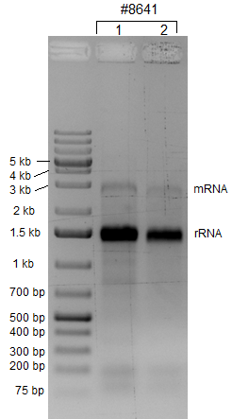
Figure 12: Extraction of RNA from flies;.mRNA and rRNA from Da driver line (8641) flies shows bands on 3 kb and 1.5 kb on1% agarose gel.

After RNA extraction, we performed a reverse-transcriptase PCR to obtain the cDNA. With the cDNA, a PCR was performed to detect the T352P-Shal-FLAG expression in the fly lines. Figure 13 shows the gel with the PCR using dShal1 Forward and dShal1-FLAG Reverse primers that only amplified the T352P-Shal-FLAG transgene expression, and not the endogenous Shal. Flies from Balancer chromosome 2, Balancer chromosome 3 and Double Balancer were used as a negative control. pUAST-Shal1-wt and pUAST-Shal1-T352P cDNA (previously obtained) were used as positive controls. We used isolated RNA from line T352P-3 as a negative control, to see if there was no DNA contamination. Please note that not all Shal-T352P/Da lines are present in this example. Line T352P-3 and T352P-4 showed the correct size band of 314 bp. However, the T352P-2 and T352P-3 negative controls were also positive but was negative forT352P-4. No product was observed in all the wild type controls. In addition, the RNA control was positive, so despite the good RNA isolation, there might have been contamination with DNA. Due to time problems, no expression could be determined of the Shal-wt/Da lines
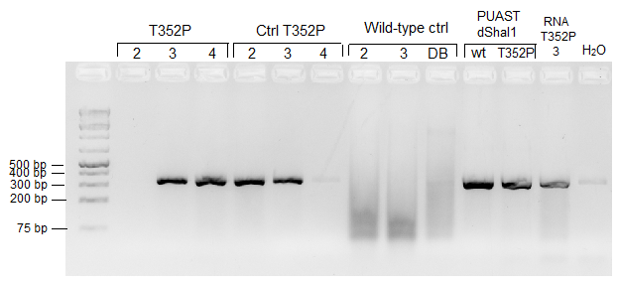
Figure 13: SHal-flag-T352P RNa expression under the Da promoter. PCR products on 2% agarose gel. Line T352P-3 and T352P-4 are positive. Control line T352P-2 and T352P-3 are positive. The balancer lines 2,3 and double-balancer (DB) used as a controls are negative, same as the negative control (water). The positive controls are positive and the RNA of line T352P-3 is positive.

Using the cDNA obtained from the active Shal-T352P/Da lines, we performed a q-PCR to quantify the expression of Shal-T352P transgene, using primers that are able to amplify both the endogenous and transgenic Shal. The expression of Shal is shown in figure 15. The white eyed flies were used as a control for the Shal-T352P lines. Three lines, balancer chromosome 2, balancer chromosome 3 and double balancer chromosome, were included as a wild-type controls. The expression in all the Shal-T352P, Shal-T352P controls and wild-type lines were equal. This suggests that only endogenous Shal was expressed in the flies and that Shal-T352P was not expressed under the Da promoter 8641 line. Due to time problems, no expression could be determined of the Shal-wt/Da lines

Figure 14: Quantification of Shal-T352P RNA expression levels. Shal1T352P flies were crossed with Da driver. The white eyes flies were controls for each line. The expression in all samples, controls and the wild type controls were equal.

To see if the protein expression of Shal-T352P in flies were correlated with the RNA levels, whole cell extracts were generated from the corresponding fly lines and the proteins were analysed via Western blot. Figure 14 shows that no Shal-T352P protein was detected in all fly samples including the Shal-T352P having red-eyes and the white-eyed w1118 controls. The pUAST-Shal1-wt and pUAST-Shal1-T352P protein extracts from HeLa cells were used as positive controls. These controls showed high molecular bands at ~150 kDa according with the expected Shal complexes. Actin was visible in all samples, except for Shal-T352P line 6.

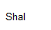
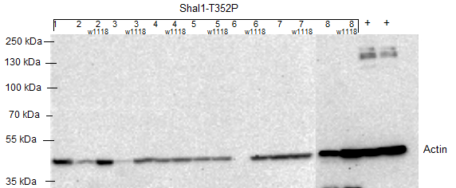

Figure 15: Expression of Shal-T352 proteins in the active Da transgene. Protein expression patterns of Shal-T352P. Proteins from the flies were extracted and 50 µg of protein was loaded to perform the Western Blot. Upper part was incubated with anti-FLAG and the lower part was incubated with anti-actin. The positive controls were pUAST-Shal1-wt-FLAG and PUAST-Shal1-T352P-FLAG. Actin is visible at 42 kDa,. Higer complexes of Shal were detected at ~150 kDa in the positive controls.

Altogether, the data obtained from the q-PCR and the Western blot clearly showed that the Shal-T352P/Da lines did not give expression of the ShaI transgene.

Expression of Shal-wt and Shal-T352P mutant in the fly eye.

Some neurodegenerative disorders fly models such as SCA3 [31] show degeneration of the eye ommatidia and the associated loss of Rhodopsin (eye-specific protein) can be used as a marker for neurodegeneration. To check for any eye degradation phenotype in the Shal1-T352P line, the UAS-wild type and UAS-Shal-T352P fly lines were crossed with the eye driver line GAL4-GMR/Cyo (GMR, #1104),that would enable expression of the Shal transgene only in the eye of the fly.

In order to check the expression of wild type and T352P Shal proteins in the eyes, a Western Blot of protein extraction from the various fly heads was done using anti-FLAG antibody. In figure 16, HeLa extracts containing pUAST-Shal-wt was used as a positive control (+) and flies from Balancer chromosome 2 were used as a negative control (-). Shal1-wt-4, Shal1-wt-5, Shal1-wt-7 and Shal1-T352P-1/GMR, showed the higher complexes of Shal, but no monomeric protein was detected. Please note that not all T352P-Shal1/GMR lines are present. The actin control was present in all samples, indicating equal loading. Analysis with Rhodopsin antibody detected bands at ~25 kDa but not in all samples. In addition, the estimate molecular weight for Rhodopsin should be ~40 kDa.

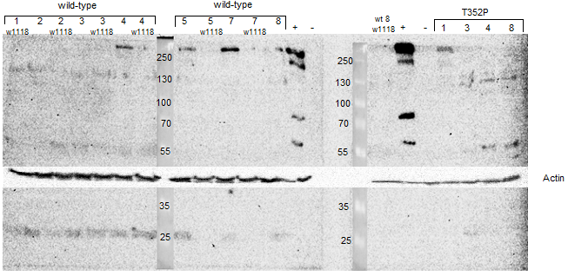
Shal
Rhodopsin
Figure 16: Expression of Shal-wt and Shal-T352P under the GMR promoter. Protein from the fly heads were extracted and 25 µg was leaded to perform the Wester Blot. Upper blot was incubated with anti-FLAG. Lower blot was first incubated with anti-Rhodopsin and developed. Blot was washed and incubated with anti-actin. The higher Shal complexes are shown on ~250 kDa. The actin control is visible at ~42 kDa. The part incubated with anti-Rhodopsin show bands at ~25 kDa.

This data suggests under the GMR promoter, the transgene Shal-wt and Shal-T352P lines gets expressed as wt and T352P Shal protein on the Western blot was detected. However, we could not detect any neurodegenerative phenotype in the ommatidia of the mutant line eyes compared with the wild type.

Discussion and conclusion

This study focuses on the effects of the T352P mutation on the Shal/Kv4 potassium channel. In previous studies the T352P mutation in Kv4.3 caused severe loss of Purkinje cells leading to spinocerebellar ataxia type 19 [4]. Functional and expression experiments could possibly unravel the effects of this mutation on the function of the channel, neuronal cell survival and motor coordination. Therefore it was decided to use a Drosophila transgenic model to investigate these effects.

The T352P mutation in Kv4.3 cause retention of the protein in the endoplasmatic reticulum (ER) of the HeLa cells and also in the soma of the Purkinje cells [4]. However, it is unknown how the T352P mutation in the Shal/Kv4 potassium channel causes Purkinje cell death. In the first experiment, we tested the localization of wild type and T352P mutated Shal in HeLa cells. This was done to determine if Shal-T352P, which is a membrane protein, localises in the plasma membrane. Figure 8 indicates that Shal wild type transfected in HeLa cells showed localisation to the membrane, while Shal-T352P transfected HeLa cells showed ShaI retention in the ER. This indicated that the localization of the protein is altered due to the T352P mutations from the membrane to the ER accordingly with our previous results.

We received the UAS-Shal1-wt/T352P fly lines from BestGene Inc. The UAS-Shal-wt came later than the UAS-Shal-T352P line. Because those flies arrived later, we had less time to execute experiments with this line. At first, to see in which chromosome the transgene was integrated into the genome, the flies were balanced with balancer chromosome with unique phenotypical features. Table V shows in which chromosome the channel was integrated. Not all UAS-T352P-Shal fly line could be mapped. It is possible that the flies could have multiple inserts at different chromosomes or at X chromosome so the mapping therefore was not possible. All the UAS-Shal-wt lines could be mapped, except for line 6, which was integrated in X chromosome. Sanger sequencing was done on the genomic DNA of the flies to check where exactly the transgenes were integrated and if the integration did not affect any other genes. Unfortunately, Sanger sequencing of the genomic DNA of the flies was not successful. Many conditions were tested, but the sequences were illegible. The peaks were short and double or triple peaks were observed, maybe due to unspecific binding of the primers since we obtained the same pattern for the wild type (with white eyes, the control of the mutant lines) and for the mutant lines. If the primers were the problem, we could sequence the plasmids which contain also the P-elements as a positive control. Otherwise, we had to make new primers.

Additionally, to usage of the Gal4-Da line was not a success. We were unable to confirm expression of our transgene in the Shal-T352P/Da lines via PCR (figure 13). Only line T352P-4/Da showed the correct band representing the transgene and its control line did not. Additionally, the RNA control of line T352P-3 was positive, so the RNA must have been contaminated with genomic DNA. To be sure that the RNA isolation method work without contamination of genomic DNA of the fly, RNA was run on agarose gel to see if there was contamination. Figure 12 shows that there was no clear contamination of genomic DNA (genomic DNA of Drosophila should run high on the agarose gel, this was not the case), however, the RNA sample gave a specific band, so, this meant that we had genomic contamination undetectable in the agarose gel. For further experiments, a DNase treatment could be done to remove all the DNA in the isolated RNA samples.

Since investigation of the transgene was hard in these RNA samples, we decided to perform a q-PCR detecting endogenous ShaI. We hypothezed that in the ShaI/Da lines, the levels of ShaI had to show increased levels compared to their control lines. The RNA expression of Shal was in all samples equal. These results did not correspond to our hypothesis. One explanation could be that the Da driver line was not able to activate the UAS promoter properly, and thus was not giving the necessary levels of transgene expression. Or there was an error in the selection of the line, either because the UAS-Gal4 mechanism gave false positive results or that the Da driver line had been mutated through the many fly generations.
Furthermore, the Western blot (figure 15) did not show any expression of Shal-T352P protein. Because mutant Shal protein was not detected, a q-PCR was done to check expression levels.

Since other SCA proteins have been shown to have neurotoxic effects on the eye of the fly, we hypothesized that our SCA19 transgenic flies could display this effect too. Overexpression of the disease gene may cause neurodegeneration in the eyes of Drosophila which may leads to fusion of the ommatidia and loss of pigment and Rhodopsin [32]. To unravel the neurotoxic effect of Shal T352P in Drosophila, we expressed Shal-wt and T352P mutant in the fly eye using the eye driver line (GMR). Here, in contrast to the active Da lines, we were able to detect wt and Shal-T352P-FLAG in the heads of the flies using Western blot.

Since we had proper expression we decided to check for the neurotoxic effect in the fly eye. 14 days old T352P and wild-type ShaI/GMR flies, in comparison with control lines, did not show degeneration of the eyes (data not shown). Here, the flies could be too young to observe eye degradation. Since SCA19 patients have slow progressive neurodegeneration, maybe the eye degradation cannot be observed. Additionally, we were unable to detect Rhodopsin levels by Western blot in the eyes. The bands that were detected were 25 kDa, and this does not correspond with the right weight. This suggest that this is an unspecific band or the Rhodopsin migrated faster through the SDS page. There was no positive control included in the blot, but the cell extract used as a positive control for anti-FLAG, we did not detect any bands. This control was not fly specific. A positive control we could use that is fly specific for this experiment, could be a SCA3 fly line crossed with the same eye driver line. We believe that the antibody that was used to detect Rhodopsin did not work properly.

Although this model still can explain the effects of the T352P mutation in Shal/Kv4 due to material and time problems not all experiments could be executed. It was bad luck that the Da-active fly lines did not give any transgene expression. So another driver line, for example an actin driver, could be used to do future expression experiments. Also, we had problem with the RNA extraction and potential DNA contamination during the isolation of RNA, but this was not detectable (figure 12). To solve this problem, a RNA extraction kit could be used or a DNase treatment could be performed. The delay of the wild-type line was just bad luck. There was no q-PCR data available, only the Western blot of the GMR-active lines. The underlying effects of the T352P mutation in SCA19 using a Drosophila model remain to be elucidated. Further studies will be needed to unravel the SCA19 mutation in the Drosophila model.

The conclusion of this report is that the mutant Shal-T352P is not transported to the plasma membrane of the HeLa cells, but stays in the ER. The Da-active lines did not express Shal-T352P as Shal expression of the mutant compared with the controls were equal but the GMR-active lines did express Shal-T352P. Despite the expression of the mutant channel in the eye, no eye degradation was observed. Line T352P-4 is a possible candidate to use for further experiments, because the PCR was positive and the w1118 control was negative for FLAG. Finally, the mutation did not cause a decreased expression of Shal. However, since the Kv4 channels do not localize properly to the membrane, there might be difference of Shal/Kv4 activity on the membrane.

Literature list

1. Schelhaas, H.J., Ippel, P.F., Hageman, G., Sinke, R.J., van der Laan, E.N., Beemer, F.A. (2001) Clinical and genetic analysis of a four-generation family with a distinct autosomal dominant cerebellar ataxia. J Neurol 248, 113-20.
2. Schelhaas, H.J.,van de Warrenburg, B.P. (2005) Clinical, psychological, and genetic characteristics of spinocerebellar ataxia type 19 (SCA19). Cerebellum 4, 51-4.
3. Verbeek, D.S., Schelhaas, J.H., Ippel, E.F., Beemer, F.A., Pearson, P.L., Sinke, R.J. (2002) Identification of a novel SCA locus ( SCA19) in a Dutch autosomal dominant cerebellar ataxia family on chromosome region 1p21-q21. Hum Genet 111, 388-93.
4. Duarri, A., Jezierska, J., Fokkens, M,. (2012) Mutations in potassium channel KCND3 cause spinocerebellar ataxia type 19. Submitted to Annals of Neurology.
5. Zhuchenko, O., Bailey, J., Bonnen, P., Ashizawa, T., Stockton, D.W., Amos, C., Dobyns, W.B., Subramony, S.H., Zoghbi, H.Y., Lee, C.C. (1997) Autosomal dominant cerebellar ataxia (SCA6) associated with small polyglutamine expansions in the alpha 1A-voltage-dependent calcium channel. Nat Genet 15, 62-9.
6. Waters, M.F., Minassian, N.A., Stevanin, G., Figueroa, K.P., Bannister, J.P., Nolte, D., Mock, A.F., Evidente, V.G., Fee, D.B., Muller, U., Durr, A., Brice, A., Papazian, D.M., Pulst, S.M. (2006) Mutations in voltage-gated potassium channel KCNC3 cause degenerative and developmental central nervous system phenotypes. Nat Genet 38, 447-51.
7. Verbeek, D.S., van de Warrenburg, B.P., Wesseling, P., Pearson, P.L., Kremer, H.P., Sinke, R.J. (2004) Mapping of the SCA23 locus involved in autosomal dominant cerebellar ataxia to chromosome region 20p13-12.3. Brain 127, 2551-7.
8. Finsterer, J. (2009) Ataxias with autosomal, X-chromosomal or maternal inheritance. Can J Neurol Sci 36, 409-28.
9. Schelhaas, H.J., van de Warrenburg, B.P., Hageman, G., Ippel, E.E., van Hout, M., Kremer, B. (2003) Cognitive impairment in SCA-19. Acta Neurol Belg 103, 199-205.
10. O'Sullivan Smith, C., (2004) Spinocerebellar Ataxia: Making an Informed Choice About Genetic Testing, Seattle: U. S. Department of Education.
11. Bird, T.D., (2012) GeneReviews™ [Internet] Hereditary Ataxia Overview, Seattle (WA) USA: University of Washington. Available from: http://www.ncbi.nlm.nih.gov/books/NBK1138/.
12. Duenas, A.M., Goold, R., Giunti, P. (2006) Molecular pathogenesis of spinocerebellar ataxias. Brain 129, 1357-70.
13. Chung, M.Y., Lu, Y.C., Cheng, N.C., Soong, B.W. (2003) A novel autosomal dominant spinocerebellar ataxia (SCA22) linked to chromosome 1p21-q23. Brain 126, 1293-9.
14. Birnbaum, S.G., Varga, A.W., Yuan, L.L., Anderson, A.E., Sweatt, J.D., Schrader, L.A. (2004) Structure and function of Kv4-family transient potassium channels. Physiol Rev 84, 803-33.
15. Postma, A.V., Bezzina, C.R., de Vries, J.F., Wilde, A.A., Moorman, A.F., Mannens, M.M. (2000) Genomic organisation and chromosomal localisation of two members of the KCND ion channel family, KCND2 and KCND3. Hum Genet 106, 614-9.
16. Yang, E., Alvira, M., R. (2000) Kvβ Subunits Increase Expression of Kv4.3 Channels by Interacting with Their C Termini. The Journal of Biological Chemistry 276, 4839-4844.
17. Rhodes, K., . J., Carroll, K., I. (2004) KChIPs and Kv4 α Subunits as Integral Components of A-Type Potassium Channels in Mammalian Brain. The Journal of Neuroscience 24, 7903-7915.
18. Wang, H., Yan, Y., Liu, Q., Huang, Y., Shen, Y., Chen, L., Chen, Y., Yang, Q., Hao, Q., Wang, K., Chai, J. (2007) Structural basis for modulation of Kv4 K+ channels by auxiliary KChIP subunits. Nat Neurosci 10, 32-9.
19. Adams, M.D., Celniker, S.E., Holt, R.A., Evans, C.A., Gocayne, J.D., Amanatides, P.G., Scherer, S.E., Li, P.W., Hoskins, R.A., Galle, R.F., George, R.A., Lewis, S.E., Richards, S., Ashburner, M., Henderson, S.N., Sutton, G.G., Wortman, J.R., Yandell, M.D., Zhang, Q., Chen, L.X., Brandon, R.C., Rogers, Y.H., Blazej, R.G., Champe, M., Pfeiffer, B.D., Wan, K.H., Doyle, C., Baxter, E.G., Helt, G., Nelson, C.R., Gabor, G.L., Abril, J.F., Agbayani, A., An, H.J., Andrews-Pfannkoch, C., Baldwin, D., Ballew, R.M., Basu, A., Baxendale, J., Bayraktaroglu, L., Beasley, E.M., Beeson, K.Y., Benos, P.V., Berman, B.P., Bhandari, D., Bolshakov, S., Borkova, D., Botchan, M.R., Bouck, J., Brokstein, P., Brottier, P., Burtis, K.C., Busam, D.A., Butler, H., Cadieu, E., Center, A., Chandra, I., Cherry, J.M., Cawley, S., Dahlke, C., Davenport, L.B., Davies, P., de Pablos, B., Delcher, A., Deng, Z., Mays, A.D., Dew, I., Dietz, S.M., Dodson, K., Doup, L.E., Downes, M., Dugan-Rocha, S., Dunkov, B.C., Dunn, P., Durbin, K.J., Evangelista, C.C., Ferraz, C., Ferriera, S., Fleischmann, W., Fosler, C., Gabrielian, A.E., Garg, N.S., Gelbart, W.M., Glasser, K., Glodek, A., Gong, F., Gorrell, J.H., Gu, Z., Guan, P., Harris, M., Harris, N.L., Harvey, D., Heiman, T.J., Hernandez, J.R., Houck, J., Hostin, D., Houston, K.A., Howland, T.J., Wei, M.H., Ibegwam, C., Jalali, M., Kalush, F., Karpen, G.H., Ke, Z., Kennison, J.A., Ketchum, K.A., Kimmel, B.E., Kodira, C.D., Kraft, C., Kravitz, S., Kulp, D., Lai, Z., Lasko, P., Lei, Y., Levitsky, A.A., Li, J., Li, Z., Liang, Y., Lin, X., Liu, X., Mattei, B., McIntosh, T.C., McLeod, M.P., McPherson, D., Merkulov, G., Milshina, N.V., Mobarry, C., Morris, J., Moshrefi, A., Mount, S.M., Moy, M., Murphy, B., Murphy, L., Muzny, D.M., Nelson, D.L., Nelson, D.R., Nelson, K.A., Nixon, K., Nusskern, D.R., Pacleb, J.M., Palazzolo, M., Pittman, G.S., Pan, S., Pollard, J., Puri, V., Reese, M.G., Reinert, K., Remington, K., Saunders, R.D., Scheeler, F., Shen, H., Shue, B.C., Siden-Kiamos, I., Simpson, M., Skupski, M.P., Smith, T., Spier, E., Spradling, A.C., Stapleton, M., Strong, R., Sun, E., Svirskas, R., Tector, C., Turner, R., Venter, E., Wang, A.H., Wang, X., Wang, Z.Y., Wassarman, D.A., Weinstock, G.M., Weissenbach, J., Williams, S.M., WoodageT, Worley, K.C., Wu, D., Yang, S., Yao, Q.A., Ye, J., Yeh, R.F., Zaveri, J.S., Zhan, M., Zhang, G., Zhao, Q., Zheng, L., Zheng, X.H., Zhong, F.N., Zhong, W., Zhou, X., Zhu, S., Zhu, X., Smith, H.O., Gibbs, R.A., Myers, E.W., Rubin, G.M.,Venter, J.C. (2000) The genome sequence of Drosophila melanogaster. Science 287, 2185-95.
20. Barton, N.H., Briggs, D.E.G., Eisen, J.A., Goldstein, D.B., Patel, N.H., (2007) Evolution, USA: Cold Spring Harbor Laboratory Press. 833.
21. Novitski, E., Carson, H.L., Thompson, J.N., (1986) The Genetics and biology of Drosophila: Academic Press.
22. Pitnick, S. (1996) Investment in testes and the cost of making long sperm in Drosophila. American Naturalist 148, 57–80.
23. Hartwell, L., Hood, L., Goldberg, M., Reynolds, A., Silver, L., (2010) Genetics: From Genes to Genomes. 4th ed, USA: McGraw-Hill Higher Education. 816.
24. Greenspan, R.J., (2004) Fly Pushing: The Theory and Practice of Drosophila Genetics. Vol. 2nd, San Diego (USA): Cold Spring Harbor Laboratory Press.
25. Brand, A.H.,Perrimon, N. (1993) Targeted gene expression as a means of altering cell fates and generating dominant phenotypes. Development 118, 401-15.
26. Frei, C., Galloni, M., Hafen, E., Edgar, B.A. (2005) The Drosophila mitochrondrial ribosomal protein mRpL12 is required for Cyclin D/Cdk4-driven growth. EMBO J 3, 623-634.
27. Cronmiller, C.,Cummings, C.A. (1993) The daughterless gene product in Drosophila is a nuclear protein that is broadly expressed throughout the organism during development. Mech Dev 42, 159-69.
28. Duffy, J., B. (2002) GAL4 system in Drosophila: A fly geneticist's Swiss army knife. Genesis 32, 1-15.
29. Muqit, M.M.,Feany, M.B. (2002) Modelling neurodegenerative diseases in Drosophila: a fruitful approach? Nat Rev Neurosci 3, 237-43.
30. Corley, R.B., (2005) A guide to methods in the biomedical sciences, Boston, MA, USA: Springer Science.
31. Yi, J., Zhang, L., Tang, B., Han, W., Zhou, Y., Chen, Z., Jia, D., Jiang, H. (2013) Sodium valproate alleviates neurodegeneration in SCA3/MJD via suppressing apoptosis and rescuing the hypoacetylation levels of histone H3 and H4. PLoS One 8, e54792.
32. Sang, T.J., G., R. (2005) Drosophila Models of Neurodegenerative Disease. NeuroRx 3, 438-446.

Appendix I

Overview of the SCA types that are currently known.
Type | Chromosome location | Gene symbol or Chromosomal locus | Type of mutation | SCA frequency
SCA1 | 6p23 | ATXN1 | CAG repeat | 6-12%
SCA2 | 12q23-q24.1 | ATXN2 | CAG repeat | 6-12%
SCA3 | 14q21 | ATXN3 | CAG repeat | 30-35%
SCA4 | 16q22.1 | PLEKHG4 |  | rare
SCA5 | 11q13.2 | SPTBN2 | non repeat mutation | rare
SCA6 | 19p13 | CACNA1A | CAG repeat | 10%
SCA7 | 3p21.1-p12 | ATXN7 | CAG repeat | 5%
SCA8 | 13q21 | ATXN8 / ATXN8OS | CTG repeat, non coding | 3%
SCA9
SCA10 | 22q13 | ATXN10 | ATTCT repeat, non coding | rare
SCA11 | 15q15.2 | TTBK2 | non-repeat mutations | rare
SCA12 | 5q32 | PPP2R2B | CAG repeat, non coding | rare
SCA13 | 19q13.33 | KCNC3 | non-repeat mutations | rare
SCA14 | 19q13.4 | PRKCG | non-repeat mutations | rare
SCA15 | 3p26.1 | ITPR1 | Deletion of the 5' part of the gene | rare
SCA16 | 3p26.2 | ITPR1 |  | rare
SCA17 | 6q27 | TBP | CAG repeat | 1%
SCA18 | 7q22-q32 | Unknown
SCA19 | 1p21-q21 | KCND3
SCA20 | 11p11.2-q13.3 | Unknown | 260-kb duplication
SCA21 | 7p21.3-p15.1 | Unknown |  | rare
SCA22 | 1p21-q23 | KCND3 |  | rare
SCA23 | 20p13 | PDYN | Missense | rare
SCA24 | 1p36 | SCASI
SCA25 | 2p21-p15 | Unknown |  | rare
SCA26 | 19p13.3 | Unknown
SCA27 | 13q34 | Unknown
SCA28 | 18p11.21 | AFG3L2 | Missense
SCA29 | 3p26 | Unknown
SCA30 | 4q34.3-q35.1 | Unknown
SCA31 | 16q22 | Unknown
SCA32
SCA33
SCA34
SCA35 | 20p13 | TGM6 | Missense
SCA36 |  | NOP56 | GGCCTG intronic repeat expansion

http://flystocks.bio.indiana.edu/Fly_Work/media-recipes/bloomfood.htm (Visited on 21-02-2013)
http://www.flychip.org.uk/protocols/gene_expression/rna_qc.php (Visited on 6-05-2013)

